


A Guide to the London Local Skills Improvement Plan & Related Annexes

June 2026

Navigating the London LSIP Report
This document summarises and explains how the report and multiple annexes found in the London Local Skills Improvement Plan (LSIP) report combine to produce a strong case for skills improvement across London as a whole.
Introduction
The London LSIP report summarises the key findings and actionable priorities for London as a whole. The report draws together both quantitative and qualitative evidence and analysis from a wide range of sources with multiple organisations and partners involved in contributing to the narrative.
Annexes
Additional and/or more detailed information about the skills needs identified in the London LSIP can be found in Annex A. These define the key occupations and industries being targeted and map them to relevant SOC codes. Annex B contains a table of specific activities being implemented across London to support the recommended changes. These activities are split by regional areas. The Background and Methodology used to develop the core Pan-London LSIP report can be found in Annex C. All three of these documents will be treated as live documents and updated as needed throughout the LSIP lifecycle. A glossary of commonly used terms referenced throughout all the annexes and reports can also be found in Annex D
Quantitative data findings for the core Pan-London LSIP report have been drawn from an evidence base (Annex E) researched by the Greater London Authority Economics team (GLAE). A statement is also included from the Greater London Authority (GLA) to confirm the lead ERB (BusinessLDN) worked with them to develop the evidence base, gather stakeholder evidence and develop the recommended actionable priorities for the core London LSIP (Annex F).
Qualitative data findings for the London LSIP report come from extensive stakeholder events and meetings run by BusinessLDN alongside other data gathering events run by the GLA and London’s sub-regional partnerships (Central London Forward (CLF), Local London (LL), South London Partnership (SLP) and West London Alliance (WLA) from September 2025 through to March 2026.
In addition, London ERB partners (the London Chamber of Commerce and Industry (LCCI), the Confederation of British Industry London (CBI) and the Federation of Small Businesses London (FSB) were offered the opportunity to contribute to data and narrative within the report. The London LSIP report was written by WPI Economics in partnership with BusinessLDN.
Tackling the scale of London
London consists of 32 local authority districts that, together with the City of London, make up the administrative area of Greater London, England. Inner London boroughs tend to be smaller, in both population and area, and more densely populated than Outer London boroughs (Figure 1). There can be significant variation in the population characteristics, particularly when associated with employment prospects or access to skills and training services.
As a result, the London LSIP uniquely commissions four deep dive reports (Annexes G – J) to give additional depth and detail into the training provision and required skills for the LSIP within the London Boroughs. These reports were commissioned and endorsed by BusinessLDN from the London sub-regional partnerships (SRPs).
The SRPs are (in alphabetical order): Central London Forward (Annex G), Local London (Annex H), South London Partnership (Annex I) and West London Alliance / West London Business (Annex J). As with the main report, the SRP annexes were all supported with regional quantitative data analyses commissioned from the GLA Economics team. Where appropriate, SRPs commissioned additional evidence base analyses and ran their own stakeholder engagement events – all of which is detailed within their individual reports. BusinessLDN over-saw and signed-off on all SRP work.
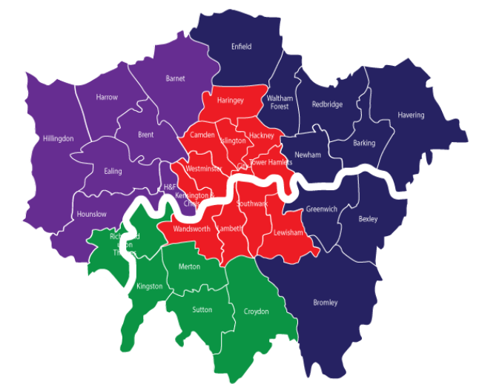
Figure 1 | Map of the four London Sub Regional Partnerships (SRPs) and the boroughs each SRP encompasses.

Supportive content
Throughout the stakeholder engagement, a number of case studies and best practice initiatives were identified. These are summarised in Annex K.
Annex L summarises the Pan-London stakeholder engagement findings and recommendations gathered during the LSIP events held by BusinessLDN and the SRPs. These qualitative findings along with the GLA Evidence Base (Annex B) were used to inform the extended Employer and Provider Consultation Events held in March 2026.

Summary of the London LSIP Report & Annexes
Annex | Title | Description
 | London LSIP Report | The LSIP Report looking at the London region as a whole
Annex A | Additional Skills Needs | Further information about the skills needs identified in the London LSIP
Annex B | Action Plan | Specific activities being implemented across London to support the recommended changes, split regionally as required
Annex C | Background and Methodology | Summary of the project approach taken by BusinessLDN and the Sub-Regional Partnerships for the LSIP project
Annex D | Glossary | A glossary of commonly used terms referenced throughout all of the LSIP reports and annexes
Annex E | Local Strategic Context – GLA Evidence Base | Quantitative evidence on the London economy & skills provision across the Capital
Annex F | GLA Statement | GLA statement on the method and approach taken in the London LSIP
Annex G | Central London Forward Report & Data | An accompanying LSIP sub-regional annex offering detailed data, actionable priorities and a roadmap specifically for Central London boroughs
Annex H | Local London Report  & Data | An accompanying LSIP sub-regional annex offering detailed data, actionable priorities and a roadmap specifically for East London boroughs
Annex I | South London Partnership Report & Data | An accompanying LSIP sub-regional annex offering detailed data, actionable priorities and a roadmap specifically for South London boroughs
Annex J | West London Business / Alliance Report & Data | An accompanying LSIP sub-regional annex offering detailed data, analysis and actions specifically for West London boroughs
Annex K | Case Studies Annex | A comprehensive list of case studies and best practices
Annex L | Stakeholder Engagement Summary | Details of the stakeholder and sector findings as presented in the Employer Stakeholder event in March 2026

Acknowledgements:
As the designated Employer Representative Body (ERB) for the London LSIP, BusinessLDN would like to acknowledge the following organisations, companies and individuals for their contribution to the London LSIP project.
Funding:
BusinessLDN and all its LSIP partners thank the UK Government for funding these research reports through the Department for Education (DfE) and Department for Work and Pensions (DWP).
Sub-Regional Partnerships:
- Central London Forward (CLF)
- Local London (LL)
- South London Partnership (SLP)
- West London Business / West London Alliance (WLA)
ERB Partners:
- The London Chamber of Commerce and Industry (LCCI)
- The Federation of Small Businesses London (FSB)
- The Confederation of British Industry London (CBI)
Report Authors working with BusinessLDN:
- WPI Economics
Data & Evidence:
- GLA Economics (London LSIP report & SRP annexes)
- Institute of Employment Studies (IES) (West London annex)
Stakeholders:
BusinessLDN would also like to thank the hundreds of individuals and companies that gave up their time to attend stakeholder events, to contribute case studies or to take part in the consultation events on behalf of the London LSIP project. Your input and guidance has been invaluable.

